CITIZEN INPUT FORM
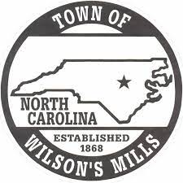
What do you feel is most important for our Town? _____________________________________________________________________________________
_____________________________________________________________________________________

What concerns do you have? _____________________________________________________________________________________
_____________________________________________________________________________________

What questions do you have about local government / the Town of Wilson’s Mills?
_____________________________________________________________________________________
_____________________________________________________________________________________

What businesses would you like to see come to our town? _____________________________________________________________________________________
_____________________________________________________________________________________

How could the Town keep the citizens of Wilson’s Mills better informed? _____________________________________________________________________________________
_____________________________________________________________________________________

What else would you like to see at our Community Park? _____________________________________________________________________________________
_____________________________________________________________________________________
What services would you like to see the Town provide to our citizens? _____________________________________________________________________________________
_____________________________________________________________________________________

What are your suggestions to make the Town of Wilson’s Mills a better place? _____________________________________________________________________________________
_____________________________________________________________________________________

How do you feel about the Police Department using cameras to better protect the community? _____________________________________________________________________________________
_____________________________________________________________________________________

How can the Police Department better serve you? _____________________________________________________________________________________
_____________________________________________________________________________________

Are there any areas in town that could use better lighting? _____________________________________________________________________________________
_____________________________________________________________________________________

Would you be interested in participating in growth and development in the Town?
If you are interested, please provide the following information.
Name _________________________________________ Phone Number _____________________
Address _____________________________________________________________________________
Email Address __________________________________________________

Would you be willing to be a volunteer in Town Events?
If you are interested, please provide the following information.
Name _________________________________________ Phone Number _____________________
Address _____________________________________________________________________________
Email Address __________________________________________________

What age group are you in?
18-35
36-45
46-55
55+
Any questions or concerns?
Contact Town Hall at 919-938-3885 or Message us on Facebook.
“Working together to promote and protect quality of life.”

